A4019-Asia-China-Shang-Guang-Spiral Horn-c 1200 BCE

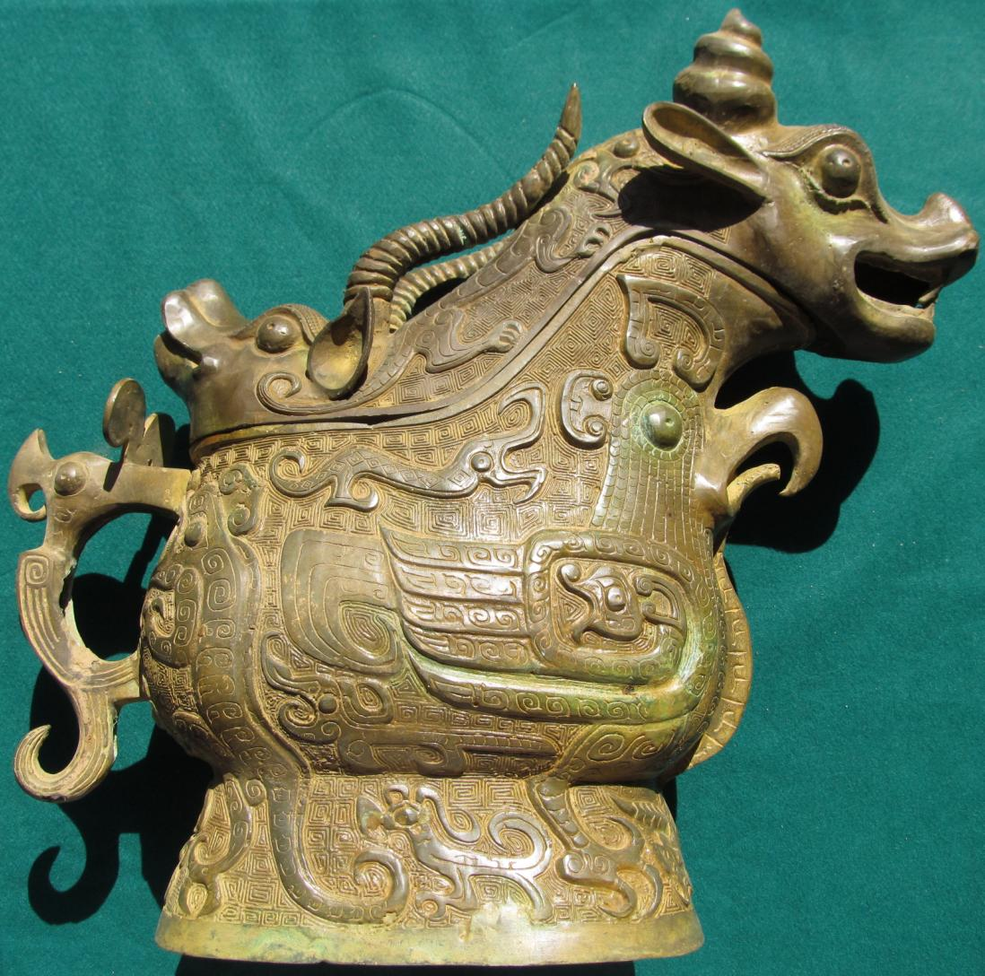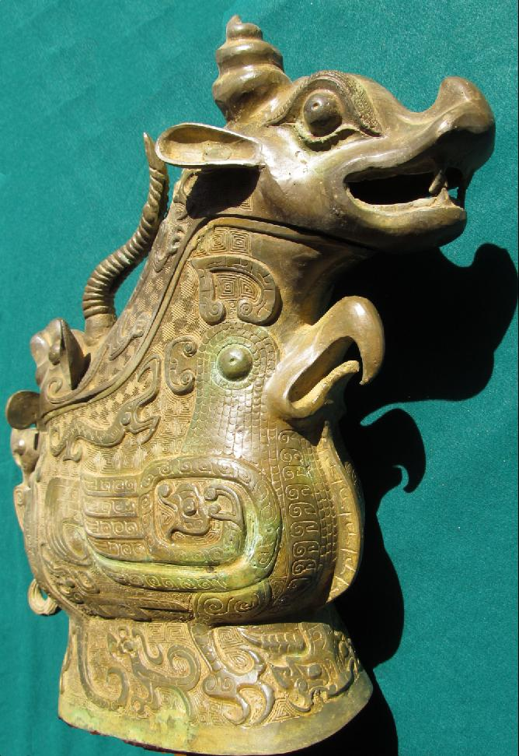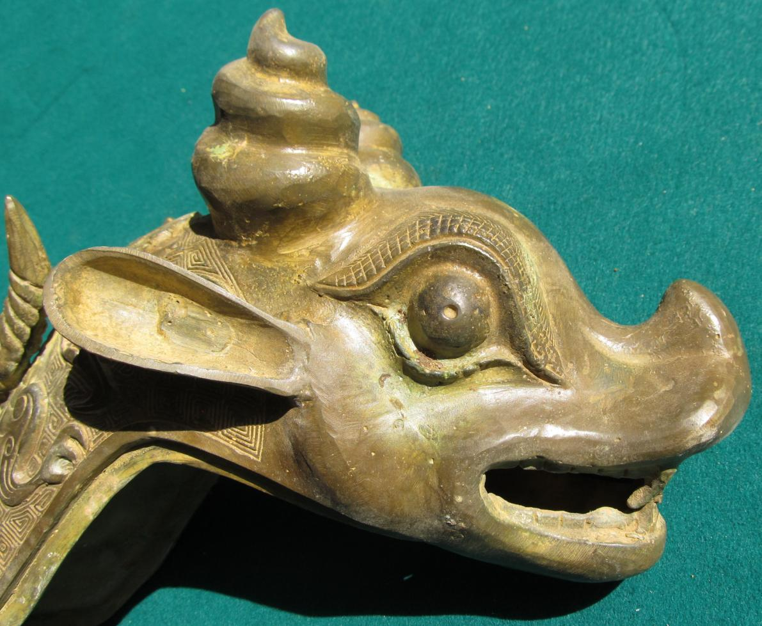

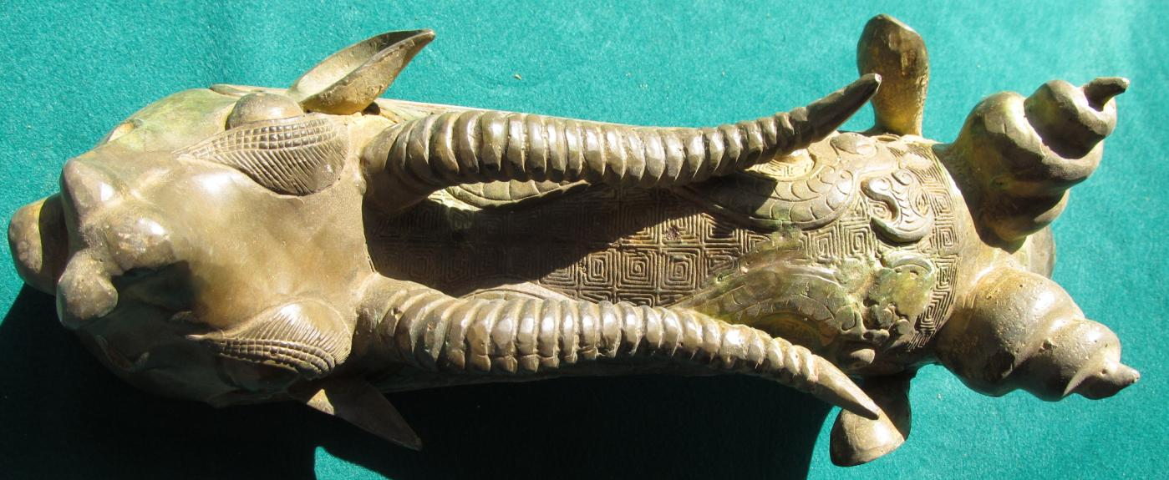

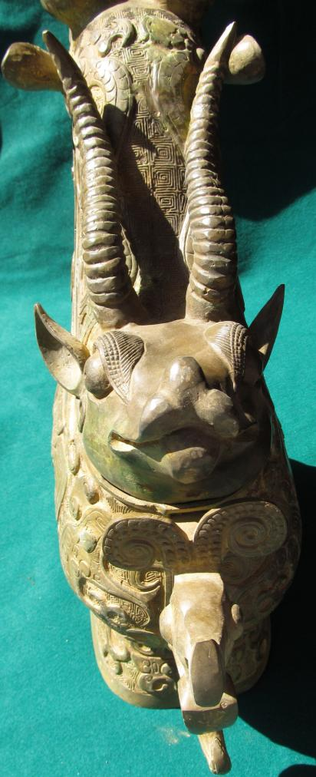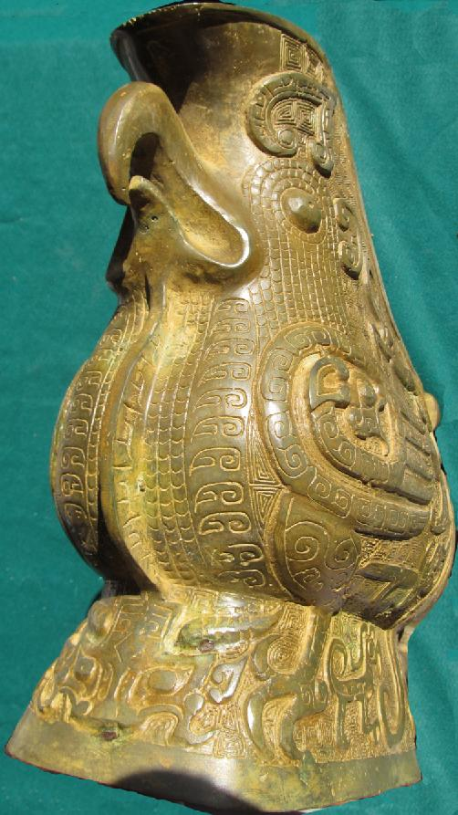

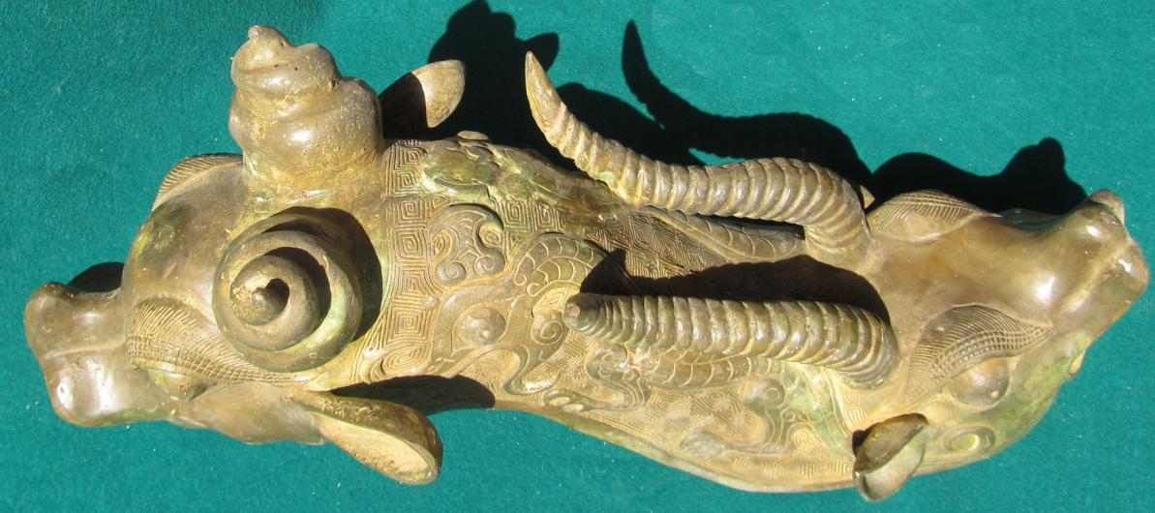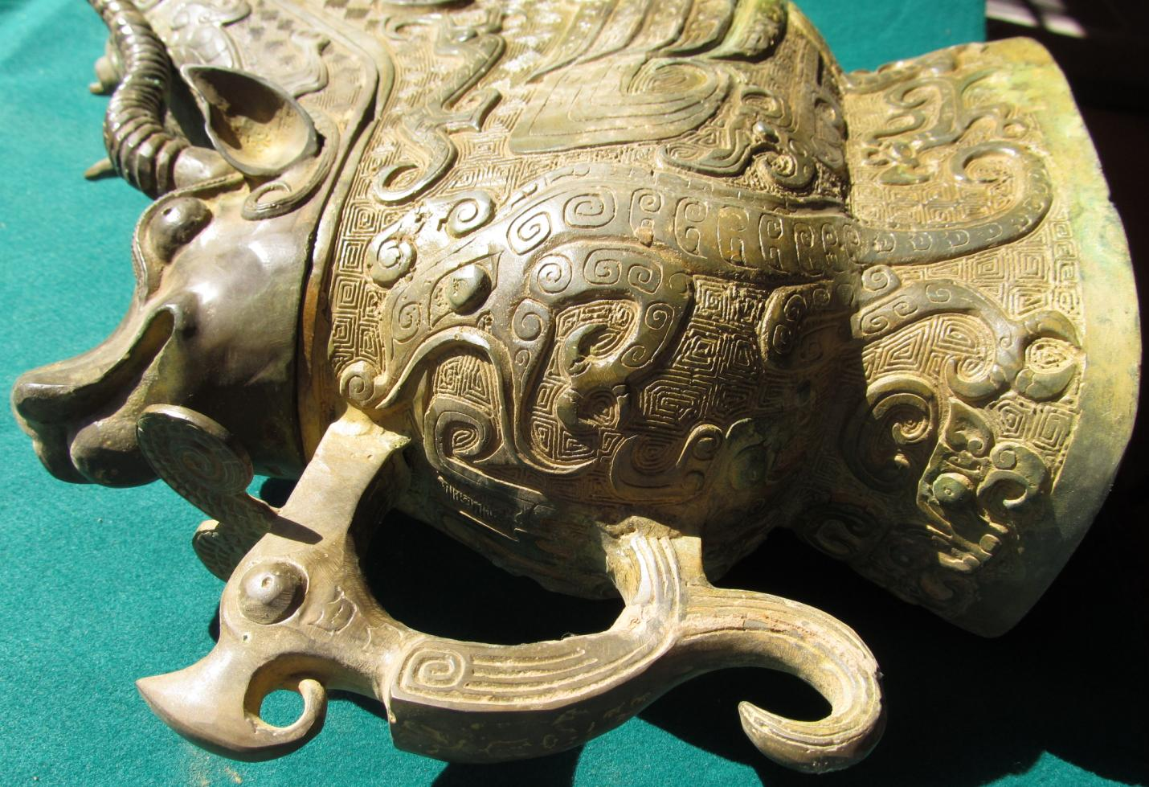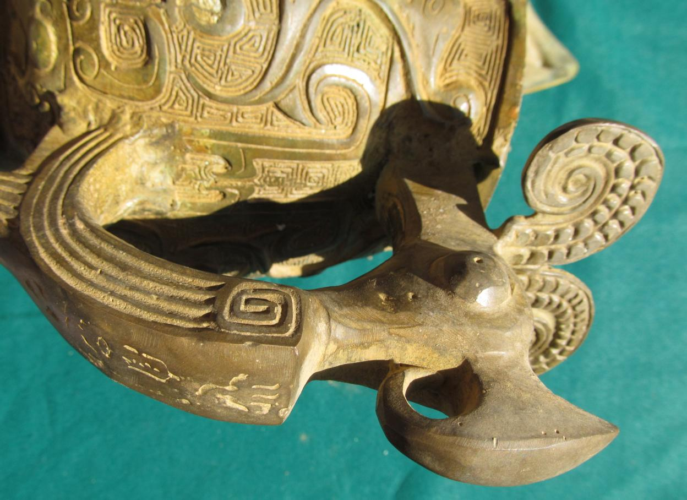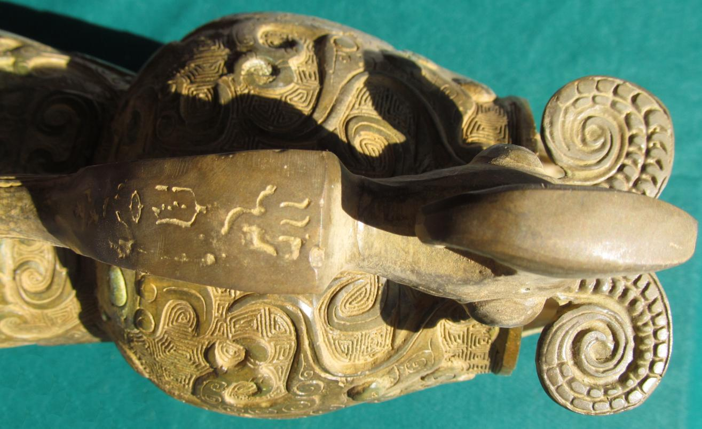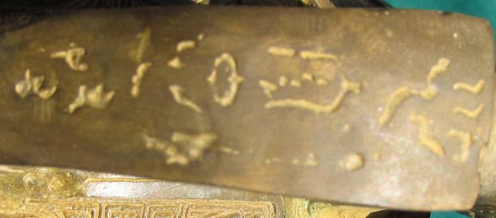

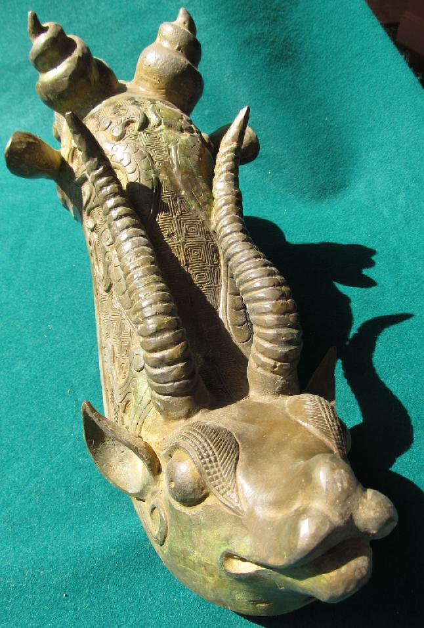

Ancient inscription.

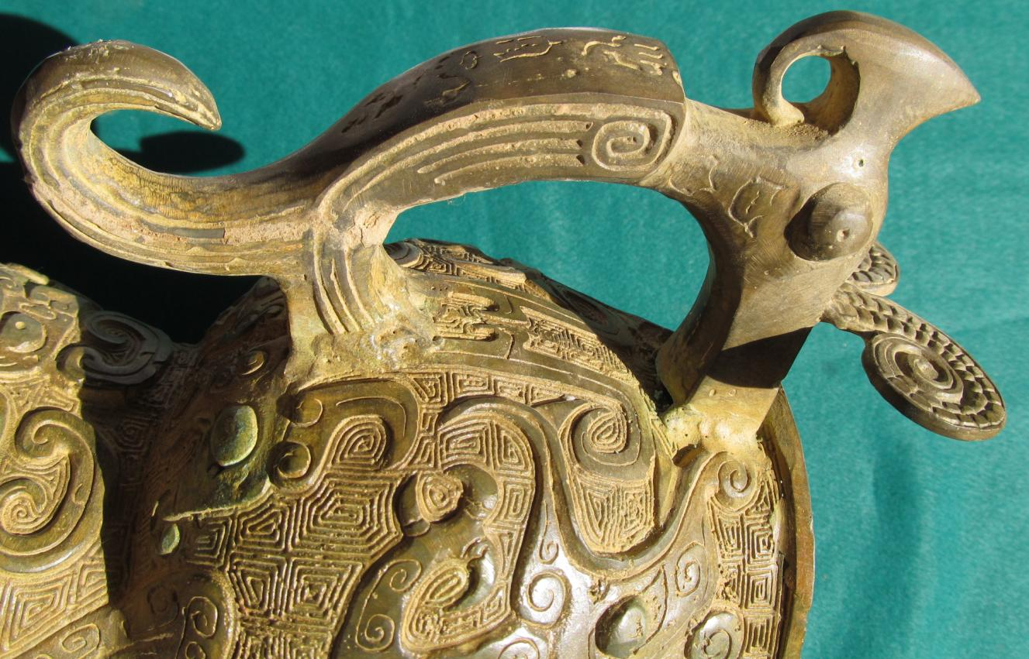

Bird-like sheep with curled horns.

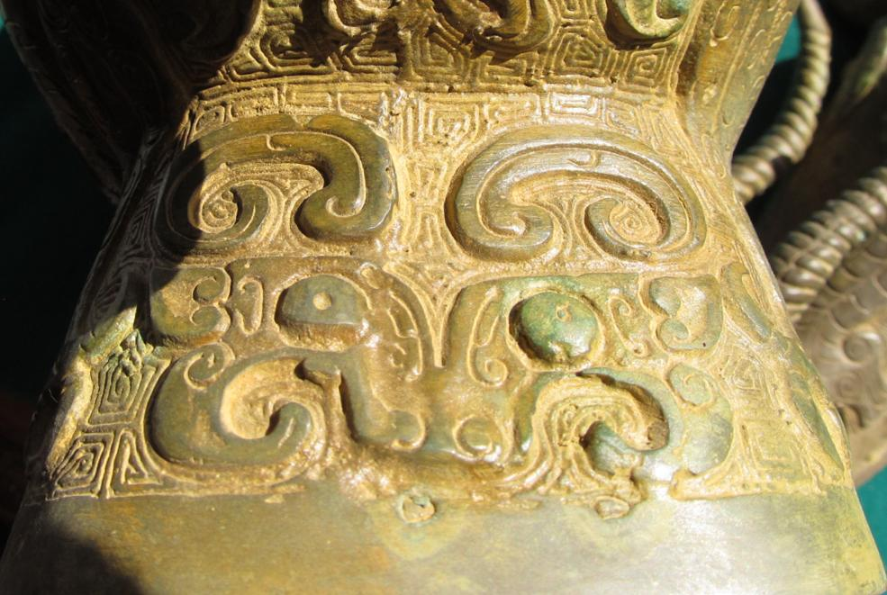

Taotie image.

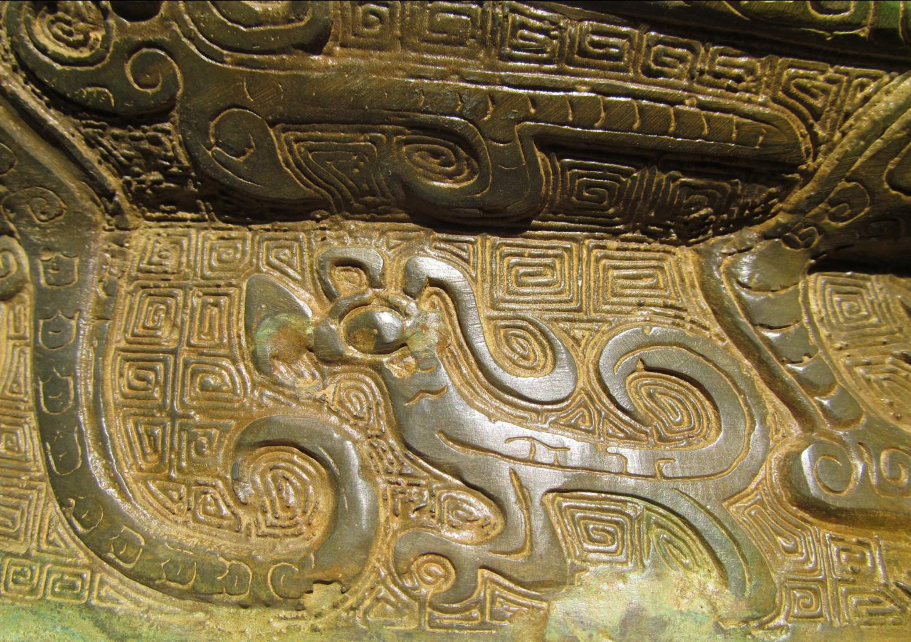

Figs. China-Shang-Guang-Spiral Horn-c 1200 BCE

**Case No.: 5**

**Accession No.**

**Formal Label:** China-Shang-Guang-Spiral Horn-c 1200 BCE

**Display Description:**

The spiral horn may be that of a fantastic version of the Markor (*capra falconeri*), a large goat, which is found today in Pakistan and Afghanistan with less than 2,500 individuals extant.

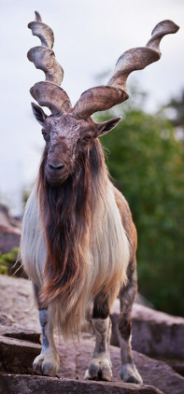

https://i.pinimg.com/originals/ae/f3/c9/aef3c979851e0330caf9ddc442f39a7b.jpg

The other species represented are other sheep/goat-like individuals.

**LC Classification:**

**Date or Time Horizon:**

**Geographical Area:**

**Map:**

**GPS coordinates:**

**Cultural Affiliation:**

**Media:**

**Dimensions:**

**Weight:**

**Condition:**

**Provenance:**

**Discussion:**

**References:**